Lustre Simulator
Qian Yingjin¹⁺, Wang Di², Nirant Puntambekar³
Abstract: Simulation has become a significant way for performance evaluations in large scale system. In this paper we will present a simulation for cluster file system Lustre. It is an efficient, accurate and configurable simulator developed to support research into various aspects of Lustre. It includes modules that simulate disks, linux-like I/O scheduler, file system, block allocator, various subsystem of Lustre such as client, object storage server, metadata server, etc. The paper first introduce the architecture of Lustre and then describes various sub components of the simulation. Then it presents a simulation case based comparing with the results from the ORNL real system which is displaying good performance and scalability, validates the reasonableness of the simulation platform. And then based on the simulator it simulates and analyzes the scaling problem in paper[4]. Finally we evaluate our Network Request Scheduler algorithm based on the simulation.
Key words: storage; Lustre; scale; simulation； Jaguar

Introduction
There has been a clear trend in the recent years towards increasing larger-scale supercomputers. One can examine the historical data provided by the Top 500 List [TOP500] to find a wealth of evidence to support this claim. Future HPC systems that are capable of running large-scale parallel applications will span thousands to tens-of-thousands of nodes. Lustre is the leading cluster file system using by many HPC supercomputers, which is running on 7 of Top 10 HPC systems and half of Top 30 ones. Examples include HP StorageWorks SFS, and Cray XT3, XD1 and Jaguar supercomputers, etc. Today’s users have demonstrated that Lustre scales down as well as it scales up, and runs in production on clusters as small as 4 and as large as 25,000 nodes.
It takes much time for researchers to test and scale their algorithms to the large cluster with hundreds and thousands of nodes. Simulation has emerged as an important instrument for studying large-scale complex systems which consist of a large number of components. It is a vital tool to quickly and inexpensively explore the behavior of large scale system. To simulate various behaviors of large scale Lustre file system, we design and develop the event-driven simulator, providing the simulation framework for evaluation the behaviors of filesystem operations at different scales for Lustre. With its help, developer can quickly diagnose and analyze the I/O problems involving large number of nodes.
In this paper we will give an overview of the Lustre simulator. The rest of the paper is organized as follows. In section 2, it presents an overview of Lustre architecture; In section 3, it describes the various components of the simulation and gives out the verification results; In section 4, it presents a simulation case based on the simulator and compares with the results on Jaguar, and then it simulates the analyzes the scaling problem by the simulator ; In section 5, it simulates the algorithm of network request scheduler based on simulator; Section 6 concludes the paper.

Lustre file system overview
Lustre is a cluster parallel filesystem designed to provide high bandwidth storage for large scale computers. The central goal of Lustre is the development of a next generation cluster file system which can serve clusters with 10,000’s of nodes, provide petabytes of storage, and move 100’s of GB/sec with state-of-the-art security and management infrastructure.
As shown in Figure about Lustre architecture, in Lustre cluster there are three major types of systems: the Clients, the Metadata Server (MDS) and Object Storage Server (OSS) systems. Lustre clients provide remote access a Lustre file system. The file system is served jointly by the Object Storage Targets (OSTs) for file contents and the Meta Data Target (MDT) for file meta data (directory struct, file size, and so on). The MDT provides backend storage for metadata and the MDS provides the network request handling for one or more local MDTs; While An OST provides backend storage for file object data (effectively, chunks of user files) and OSS provides the network request handling for one or more local OSTs. The MDTs, OSTs and Lustre clients can all run concurrently on a single node. However, a more typical configuration is an MDT on a dedicated node, two or more OSTs on each Object Storage node (OSS), and a client on each of a large number of computer nodes.
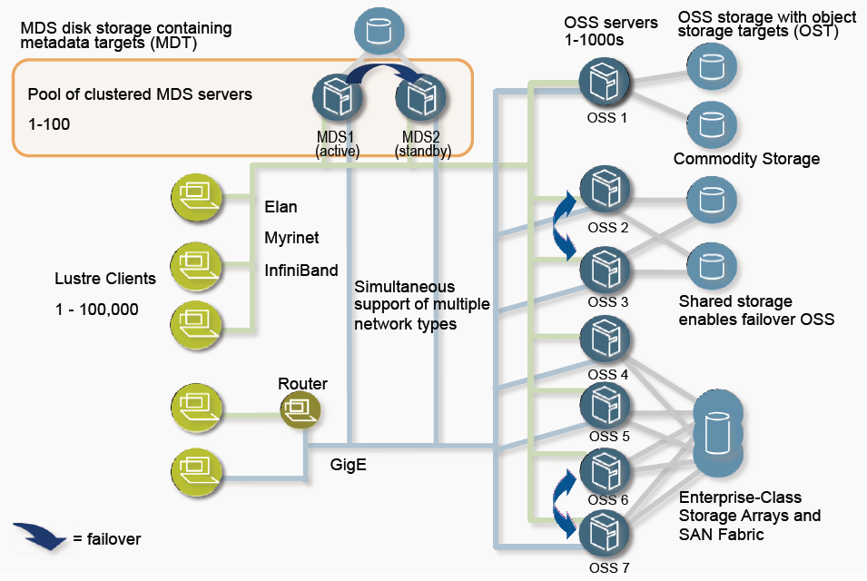
Figure 1 Lustre architecutreal diagram.
As the name implies, file metadata is held by the MDTs which maintains the global namespace of the entire file system while the file data is stripping and storing in the data objects on the OSTes. The MDTs mainly manages all the file system namespace operations such as file lookup, creation/close, file status query and it also maintains the file layout attributes that contains the references of data objects stored on OSTs. The OST is mainly responsibility for the actual file I/O and file locking from various clients. Multiple OSTs provide access to different file chunks. A single Lustre file system usually has multiple OSSes, each serving a subset of the file data. A file data may be stripping into many data objects stored on many OSTs to optimize performance.
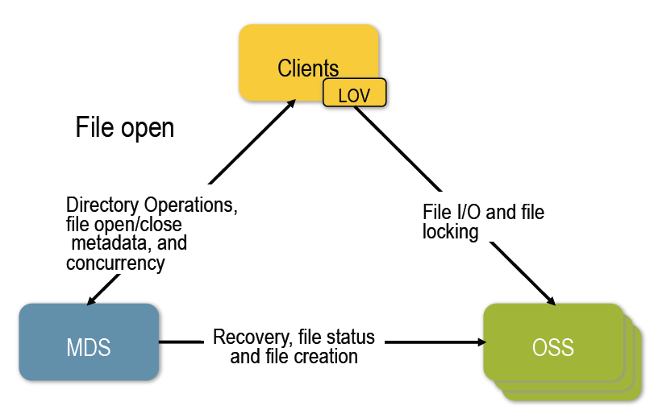
Figure 2 Outline of Interactions Between Systems.
The Lustre client software consists of an interface between the Linux Virtual File System and the Lustre servers. Each target has a client counterpart: Metadata Client (MDC), Object Storage Client (OSC). A group of OSCs are wrapped into a single Logical Object Volume (LOV) which is like a virtual device that provides object based API to the upper layer; Working in concert, the OSCs provide transparent access to the file system.
All clients which mount the file system see a single, coherent, synchronized namespace at all times.
Different clients can write to different parts of the same file at the same time, while other clients can read
from the file. This is a common situation for large simulations and is an area in which Lustre excels.
Almost all activity on the Targets is driven by requests from Lustre clients.

Lustre simulator
As the Lustre cluster scale grows up to thousands of nodes, it takes lots of time and effect to do research on such large system. Fortunately, simulation provides a powerful approach for analyzing the behaviors of I/O performance and design algorithms for such complex large-scale system. The main advantages of the simulator can be summarized in the following points:
- Simulators enable the study of complex Lustre file system;
- The effects of information and environmental changes on the model’s behavior can be analyzed;
- Simulators can be used to verify analytical modes.
- Simulators can be used to design and analyze various algorithms at very large scale.

Simulation Model
Our Lustre simulation is an Event-driven simulation developed using C++ language. In this section we describe the general structure of event-driven simulator. A set of system is specified for the simulated system, and the evolution of the system is viewed as a sequence of the form:
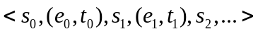
Where the ’s are system states, the ‘s are system events, and ’s are nonnegative numbers representing event occurrence times. Informally, the above sequence means that the system started, say at time 0, in state 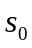; then event 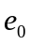 occurred at time taking the system to state ; then event occurred at time taking the system to state 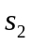; and so one. Each event occurrence is assumed to take zero time. The ’s are required to be nondecreading, i.e.,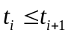 for every i.
The following variables are used in the simulator:
- Simulation Clock: Nonnegative real number, it indicates the time of the last event occurrence that has been simulated, Initially 0.
- Event List: A sequence of tuples of the form (e, t), where e is an event and t is a nonnegative real number not less than Simulation Clock. Each (e, t) tuple represents an event occurrence that is yet to be simulated. (typically the tuples in the list are sorted according to t.) Initially, the list contains one or more event occurrence pairs to trigger the simulation.
- State Variables: At the start of each iteration, these variables indicate the state of the system after the last simulated event occurrence. Initially indicates an initial system state.
Our Lustre simulation framework is based on the discrete-event-simulation principle above. Take simple simulated open/create metadata I/O path for an example: there are two states during open/create processing on MDS: {mds_createStartState, mds_createFinishState}. Supposed that It takes about 1ms for MDS to process each open/create request, at MDS receives and starts to handle an open/create request from client, first enter into state mds_createStartState; after 5ms it triggers the event that MDS finishes the open/create processing and send the reply to the client, and enter into state ms_createFinishState. The evolution sequence of the above behavior is:

Simulation components
The Lustre simulator mainly consists of the following components: Client, OST, MDT, network, file system, disk, disk elevator, etc.
The client model consists of LOV/OSC modules that use to communicate with OSTs and MDC module that uses to interaction with MDT, together with user applications to launch I/Os and waiting their completion.
Server (OST/MDT) has a backend file system and thread pool with tunable thread count that can execute the requests from various clients in parallel. And each server has a Network Request Scheduler (NRS) to manage the incoming RPC requests according to the preset NRS algorithm, where the default algorithm used by Lustre is first come first service (FCFS) algorithm. OST module implements the basic READ/WRITE/PING state machine; MDT implements a simple Open/Create and Close metadata I/O path.
File system model has implemented the basic read/write interface and uses Red Black Tree to record and manage the mapping from file logic address to disk address for each file. It implements Multiple Block Allocation (mballoc) used by Lustre backend file system ldiskfs in linux.
Network and disk models are most complex components in the simulation, the following will give out the detailed implementation and evaluation of these two models.

Network Model
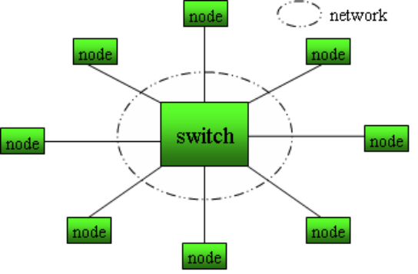
Figure 3 Network Topology.
we implement a packet-level simulation for the network model. The architecture of network model is shown in the graph above. All cluster-wide nodes are connected by a switch or connecting multiple instances of this switch in topologies, such as star or tree type, that resemble real networks.
The general principle of the network model is
- All RPC messages are spilt up into packets, where the packet size is a simulation parameter.
- The network is connected by one or multiple switches in topologies. All packets are first delivering to switch and then forward to the destination node followed “store and forward” mechanism.
- Each nodes has an NIC to send the outgoing packets to the switch one by one.
- Each switch has a destination queue per network device (node or switch) to serialize the packet delivery. It also tracks the number of packets in flight. When this exceeds the switch capacity, which is also a tunable simulation parameter, incoming packets cache and block in the blocked queue on the switch.
- When one network device finishes packet delivery, it notifies the direct source network device recursively. If the switch received the notification is blocked own to reaching its capacity, it picks the head packet in blocked queue to deliver again.
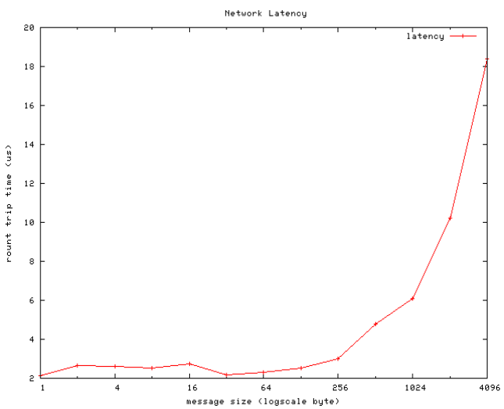
Figure 5 network latency for small message size
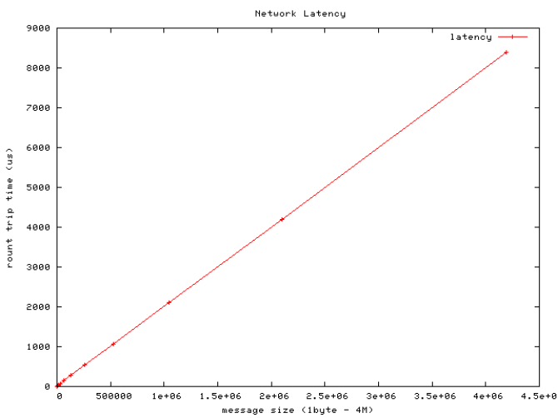
Figure 6 network latency for large message size
we did series testing against our network model with packet size 4096 bytes. The graphs above shows the latency of network model simulation which is measured by sending a packet that is returned to the sender and the round trip time is considered as the latency.

Disk model
The disk model consists of an I/O scheduler (elevator) and a simple disk driver. We implement two elevator algorithms: No-op and deadline, which support the basic functionalities of linux I/O scheduler: sort, back/front merge I/O requests by offset, plug/unplug the device with lots of pending requests under the help of timer; Hard disk driver has a queue that contains disk requests ready for handling in FCFS order.
The processing flow of I/O requests in disk model presents as follows:
- After file system issues I/O requests to disk model, similar to generic block layer in linux, the requests first submits to the I/O elevator.
- If there are no outstanding requests in elevator, set the timer with unplug delay and plug the block device. Then elevator enqueues, sorts the requests and tries to merge it with other already queued requests.
- when the number of outstanding requests exceed certain threshold (4 in linux I/O scheduler) or the timer expires, unplug the device, drain the pending requests in queue into the hard disk driver.
- Hard disk driver handles the requests one by one. The time used to handle each disk request can be followed the blew formula:
DiskTime = FixedLatency + SeekTime + IOCount/Bandwidth; where
FixedLatency indicates the time used for memory allocation, context switch, etc, for each disk request;
SeekTime means the time of each disk seek;
IOCount means the I/O bytes of the disk request;
Bandwidth means disk raw read/write bandwidth.
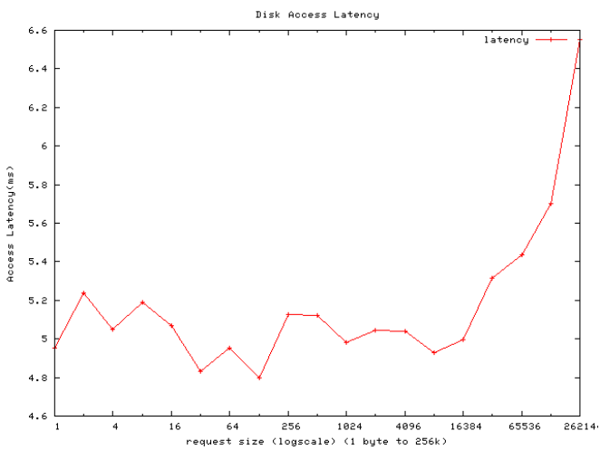
Figure 7 Disk access latency for small request size
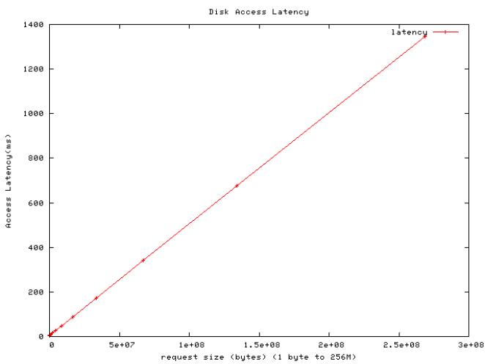
Figure 8 Disk access latency for large request size
The two graphs above show the access latency of disk model in which the FixLatency is 100 +/- 30 us, SeekTime is 5 +/- 0.8 ms, Bandwidth is 200 bytes/us (~190MB/sec). It shows that for the small I/O requests, the latency value fluctuates in 5 ms; With the growth of request size, the latency presents linear growth.
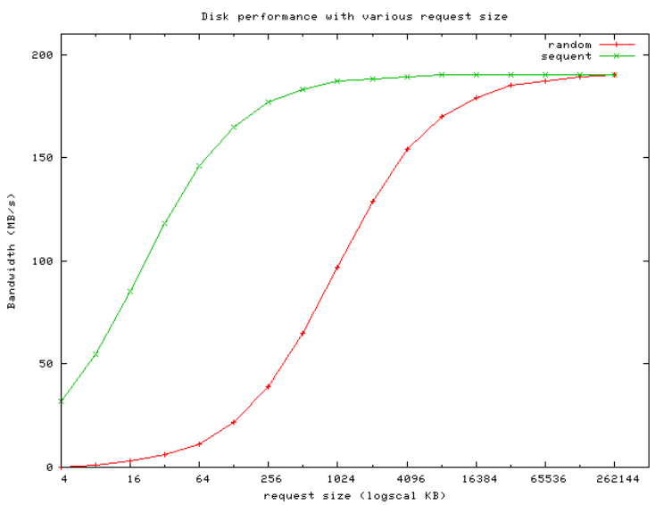
Figure 9 Disk bandwidth with various record size
The graph above shows the disk performance with various request size varying from 4k to 256M for both sequential and random access respectively. All these simulation results are very close to the real environment.

Interaction between the modules of Lustre

Client

User application
Client Lustre File System (VFS interfaces)
LOV
OSC
network

OSC
OSC
MDT
OST
OSD
ldiskfs
MDC
I/O elevator
Hard disk
OSD
ldiskfs
I/O elevator
Hard disk
MDS

OST

Figure 10 simulation components and interaction between them
The picture above shows the simulator architecture and all simulated components. In section 3.1.1 we alredy describe the metadata I/O path. In the following, we will describe the client I/O flow:
- on client user application issues the I/O request to the mounted lustre file system, waiting for the event e0 to notify completion of the I/O request.
- Lustre file system submits the request to the LOV.
- LOV splits the I/O requests into sub requests to various OSCs according to the I/O extent and stripe size of the file.
- OSC sends the sub I/O request to the corresponding OST via network and generate an event e(i) for the completion of the I/O request.
- When client receives the reply from OST that indicates that the finish of the processing for the I/O request, it trigger the event e(i) to notify the finish of the sub request.
- When finish all sub requests, it trigger event e0 to notify the user application the completion of the I/O.
In next section we will verify the simulator by comparing with the test results on real cluster environment. And then present the analysis method for the scaling problem via simulator.

Simulation

Comparison
Our primary design and development goals were to simulate reasonably large Lustre cluster file system. To verify the correctness of our simulation, we did series tests and compared the testing results of simulation with the ones of real environment from ORNL. The simulator simulates the I/O behavior of IOR (Interleaved Or Random) [IOR ] which is a parallel file system test code developed by the scalable I/O project at Lawrence Livermore national Laboratory and used to test scalability of the lustre file system by doing parallel I/O tests out to many thousands of processors.
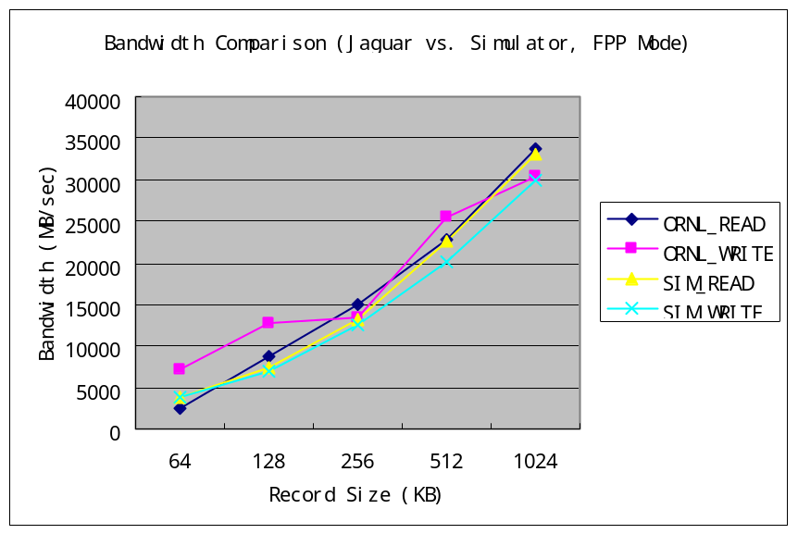
Figure 11 Bandwidth comparison
We did series testing on Jaguar which is ranked as the second fastest supercomputer as June 2007 ^{[3]}. Jaguar uses Lustre as its I/O subsystem, configured with three Lustre file systems. We did our testing on the biggest one equipped with 144 OSTs from 8192 cores (4 cores per clients) by using IOR with I/O record size varying from 64k to 1M, aggregate file size 1024GB, IOR File Per Processor (FPP) mode. With same configuration, we simulated the I/O behavior on the simulator. The graph above gives out the comparison results of performance. The performance curve shows that the max read/write bandwidths on Jaguar with 1M record size are 33.7GB/sec and 30.3GB/sec, respectively; While the simulation ones are 33.1GB/sec and 30.0 GB/sec. For small record size 64k, the read/write bandwidth on Jaguar is 2.3GB/sec and 7.0GB/sec, respectively; But the simulation ones are 3.8GB/sec and 3.9 MB/sec. Via investigation we found the possible reason was that the Jaguar used S2A 9550 from Data Direct Netwoks, Inc^{[7]} as its backend storage. DDN storage has very big hard disk cache. For write I/O considers as completion when data writes into disk cache; while for random small read, it results in cache miss and needs to read from the hard disk directly. Thus the write performance is much bigger than read performance for small record size on Jaguar. As the simulator doesn’t implement the disk cache subsystem, it doesn’t present this difference. Although there is some performance deviation between the simulation results and the ones on jaguar. But from the graph we can see that the trend of performance curve is almost same.

Scaling Analysis via Simulator
In paper [4], it gives out some scaling results for Lustre running on Cray XT3/XT4 where the scalability of Lustre was tested by keeping the aggregate file size constant wile increasing the number of clients in an attempt to more accurately simulate what a user of a large-scale XT4/XT4 machine might consider when designing a large run. The results in the paper clearly illustrate that the achievable bandwidth drops dramatically with the growth of client number after it reaches a maximum somewhere around 500 to 2,000 clients. We simulate and analyze the I/O behaviors by using the simulator.
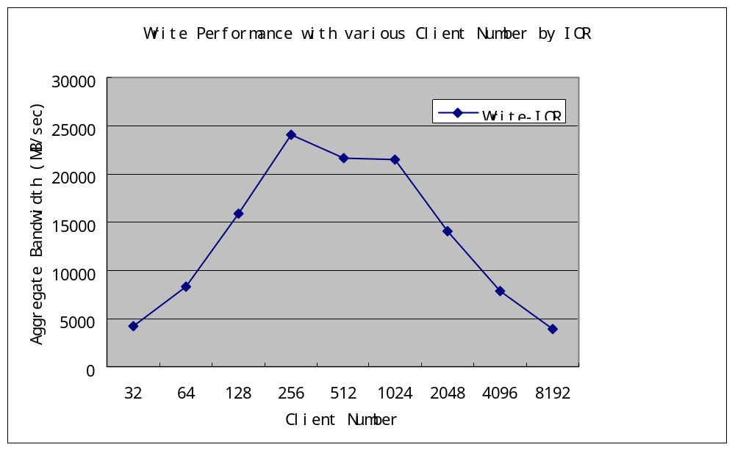
Figure 12 Write Performance with various Client Number by IOR
Similar to the Cray XT3/XT4 environment, the simulator was configured with 144 OSTs, 1 MDS, the aggregate size of the files kept constant at 16GB, testing with FPP mode (each file is only stripping over 1 OST). The Figure above shows the simulation results with client number varying from 32 t0 8192 which exhibits the similar results to Jaguar’s ones. In the Figure, the maximum write performance is approximately 24 GB/s for FPP access mode with about 500 clients. When the number of clients increases to 8192, the performance drops into only several GB/s.
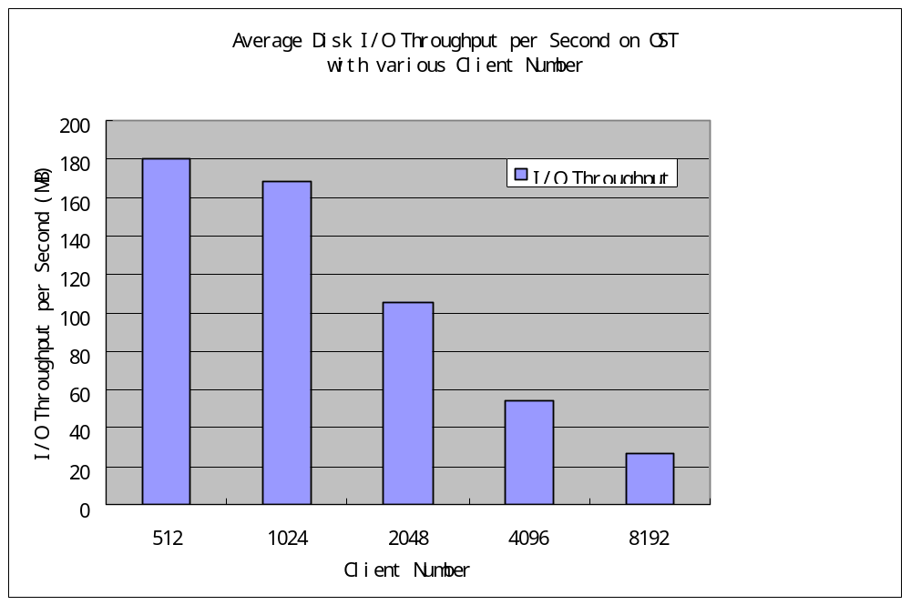
Figure 12 Average Disk I/O Throughput per Second on OST with various Client Number
In simulator, we statistics the average I/O throughput per second of the backend disk on OST. As the aggregate file size is only 16G, thus it’s 32M per client for 512 clients, 2M per client for 8192 clients. In short words, as the number of clients increases, the I/O throughput per client decreases. But the I/O amount of each OST is constant at about 110MB. Figure 12 shows that the I/O throughput per second on OST backend storage is decreasing with the increasing clients: for 512 clients, it’s 180 MB/sec; for 8192 clients, it drops to 27 MB/sec. The simulation results clearly illustrate that the I/O throughput to the backend disk is not enough to make full use of its bandwidth when client number increases more than 1024.
After further investigation, we find that much of performance drop is due to the increased time in opening/creating the separated files in FPP mode. We simulate the Open/Create metadata I/O path and statistics the number of the queued RPCs on MDT for Open/Create which is shown in Figure 12. In the simulated configuration, each MDT has 2 threads to handle the open/create requests in parallel, and each open/create request takes about 1ms. The figure shows the number of queued RPCs presents linear decreasing after reaches the maximum at the beginning several microseconds. The Figure 13 shows that total open/create time presents linear increase with the growth of client number: when client number is 512, the total open/create time takes about 0.25 second; when the client number is 8192, it reaches 4 seconds. As there is no global barrier between the file open/creation and data I/O, so some clients are already starting to write but some are still waiting for the completion of open/creation request on MDT concurrently. That’s the main reason why OST disk doesn’t get enough I/O throughputs to make full use of bandwidth as the clients involve I/O to the OST maybe still wait for open/creation. The aggregated I/O bandwidth in IOR is measured by the formula that aggregate file size divides the total I/O time. But the time for file I/O is not strictly the subtraction of the file creation time from the total time from the above analysis. That’s the reason why the aggregate bandwidth drops dramatically with the increate of client number after reaching the max. bandwidth.
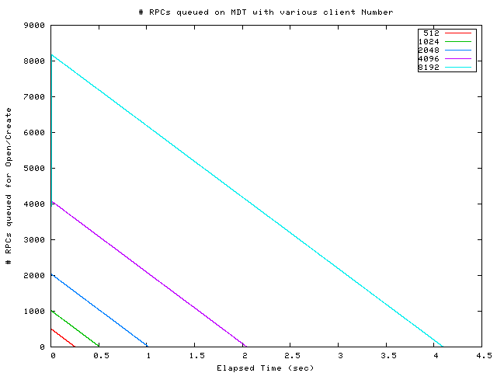
Figure 12 Number of queued RPCs for Open/Create on MDT
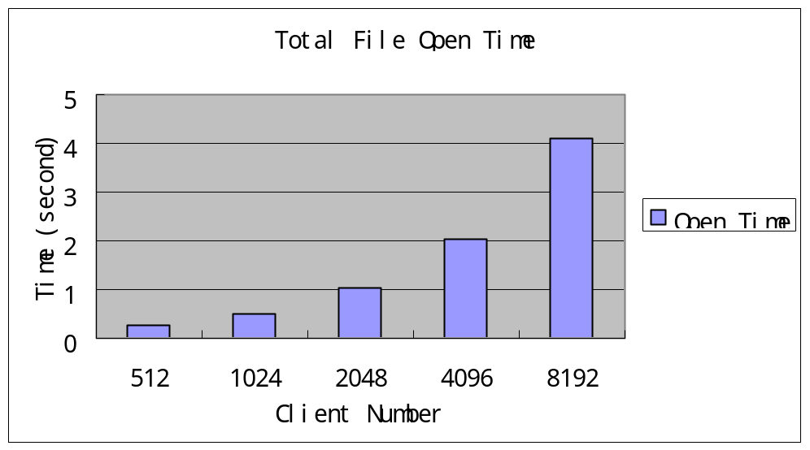
Figure 13 Total File Open Time

Design NRS Algorithms via Simulator
The main purpose of developing Lustre simulator is to design and verify the algorithm for Network Request Scheduelr (NRS) as it’s hard and time-consumed to do experiments for NRS algorithms directly on such large real cluster system.
NRS manages the incoming requests from thousand to tens of thousand clients on a server to provide improved and consistent performance by reordering request execution to avoid client stravatoin and to present a workload to the backend filesystem that can be optimized more easily. Lustre file system use ldiskfs as its backend storage system which is improved version of ext3. To improve the I/O performance, in linux it already has disk-level I/O elevator to sort, merge the I/O requests submitted to the block layer and implemented 4 elevator algorithms: No-op, deadline, CFQ, AS. NRS is a much high level -- network-level scheduling. Although the I/O throughput of the Lustre file system is excellent, but NRS can further improve the performance. As is well known disk arrays with SATA disks are much sensitive than other types of disk arrays to correct ordering of I/O requests to avoid seeks. Usually on server there is a thread pool with tens of threads to handle the RPC requests in parallel, thus the candidates of I/O requests for disk scheduler is only tens from the thousands of RPC requests cached on server; In current Lustre requests are dispatched in First Come First Server (FCFS) order that is only as faire as the network , over-reliance on disk elevator and fails to address important I/O optimization issues. NRS can group the I/O requests received from thousands of clients in a suitable order for dispatch to the backend file system, thus improve the performance by reducing the disk seek times with the help of disk elevator.
Same as the disk elevator, the main aim of NRS is also to reduce the disk seeks by reordering I/O requests to make it sequential in the disk drvier. Block allocation is the heart of a file system design. The goal of file system block allocation is to reduce disk seek time by reducing file system fragmentation. At first in the simulator the block allocation of backend file system uses a simple stream allocation algorithm, but we found that the results is not matching with the reality. Then we implement the ldiskfs mballoc algorithm. Mballoc uses space pre-allocation technology for large file. Each file has its own pre-allocation space. The count of pre-allocation space depends on the total size (S) derived out of current file size and allocation request size. E.g. if S is in (1M, 4M]，the pre-allocation size after normalization is 2M; if S is in (4M, 8M], the pre-allocation is 4M, etc.
Based on mballoc algorithm, we design a simple NRS algorithm and evaluate it based on the simulator. The principle of the NRS algorithm is, considering property of the large pre-allocation space of mballoc, make the I/O requests belong to same data object as close as possible. Thus we design a simple greedy round-robin algorithm within which the I/O requests sort by the object id and then offset for large file.
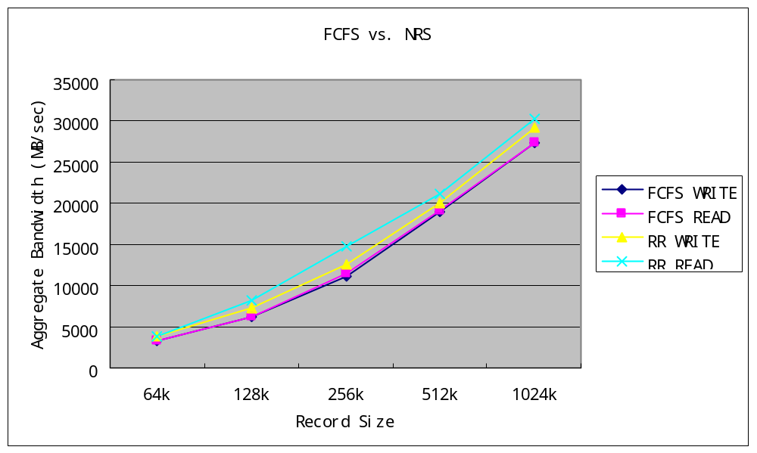
Figure 14 Performance Comparison
To evaluate the NRS algorithm, we did series experiments based on the simulator with the parameters: client number 2048, OST number 144, disk seek time 10ms (SATA type disks), raw disk bandwidth about 300 MB/sec. To eliminate the effect of open/create on performance, all benchmarks are running on opened files.
Figure 14 shows the comparing results between default FCFS algorithm and round-robin (RR) algorithm with varying record size from 64k to 1M. From the results, we can see that the read/write performance has improve about 10% after using round-robin algorithm compared with FCFS algorithm. In the simulator, we statistics the disk seeks per second in the backend Disk model. Figure 15 gives out the difference of disk seeks between FCFS and RR on OSTs which show that the disk seeks decrease dramatically by using RR algorithm. All these prove that greedy round-robin algorithm can reduce the seek time and improve the performance.
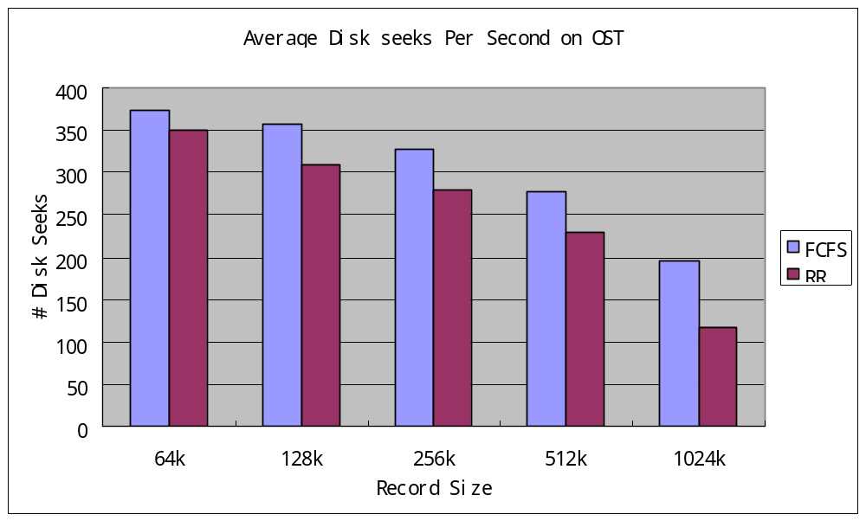 Figure 15 Disk Seek Statistic

Conclude and further work
In this paper we have introduced and described the Lustre simulator. The simulator can run with 10,000 clients, exhibiting good scalability. We have evaluated a simple NRS algorithm based on the simulator with 1000 nodes. The simulation results show the performance has improved under the NRS algorithm. This proves that the simulator significantly reduces the time used to design and develop algorithms for large-scale Lustre systems. Although the comparison between the results of simulation and the ones from ORNL lustre cluster verifies the correctness of the simulator, but the testing results is not very wellmatched. There is still much work to do such as improvement of the simple disk model, support for lustre log, I/O Locking, etc. Next step we will design much more complex NRS algorithm based on the simulator which considers many other factors such as fairness, voiding starvation and the timeout of the I/O RPC request, etc.
Acknowledgement
This research is sponsored by the Office of Advanced Scientific Computing Research; U.S. Department of Energy. The work was performed at the Oak Ridge National Laboratory, which is managed by UT-Battelle, LLC under Contract No. DE-AC05-00OR22725 with UT-Battelle, LLC.

References:
- [LUSTRE] http://www.lustre.org/
- [IOR] IOR benchmark, ftp://ftp.lanl.gov/pub/siop/ior
- [TOP500] httep://top500.org/
- Lustre manual.
- I/O Performance on a Massively Parallel Cray XT3/XT4.
- Guidelines for Efficient Parallel I/O on the Cray XT3/XT4
- Performance Characterization and Optimization of Parallel I/O on the Cray XT
- Discrete-Event Simulation.
- DDN, Products: S2A9550.

